

**A MATERIAL DESIGN STUDY APP**

**COLLEGE CODE :** 8120

**COLLEGE NAME** **:** **M.A.M COLLEGE OF** **ENGINEERING & TECHNOLOGY**

**TOTAL NUMBER OF STUDENTS :** 4

**SUBMITTED BY :**

**1.SUREGASRI . C (LEADER)**

**2.RAMPRABHA . J**

**3.SUHASINI . M**

**4.VASUNTHARA . R**

**CONTENT:**

**1.ABSTRACT**

**2.INTRODUCTION**

**3.LITERATUREREVIEW**

**4.PROPOSEDSYSTEM**

**5.IMPLEMENTATION**

**6.MODULEDESCRIPTION**

**7.FUTUREENHANCEMENT**

**8.CONCLUSION**

**ABSTRACT:**

The present Covid-19 situation pandemic forces students to attend their classes through online. This becomes a difficult task for Students to listen classes as they are facing several distractions .It also leads to Lack of communication between Students and teachers. Even students can’t take notes properly. Also there will be a library in college which helps the students to prepare for their Exams. This Project helps Teachers to upload their subject related notes, videos or Books in the App. This project can help the students in a better way than other apps So Students will feel so easy to study for their exam and also helps to gain Knowledge regarding the Subject. It reduces the teacher’s work as well. Also the app provides the students with live chat and chat assistant feature.

1. **INTRODUCTION**

The Study Material Android Application is specifically designed for SCSVMV university students. This android application aims to help the students In their academics by providing them their required study materials which are uploaded by the staffs itself so that no need for students to spend their valuable time for searching the study materials online

**Paper I**: Notes on Note-Taking: Review of Research and Insights for Students and Instructors Author: Michael C. Friedman

Description: This literature overview is designed as a resource for both students and instructors to gain insight into what education research reveals about note-taking. Specifically, this review discusses the cognitive mechanisms behind note-taking; he has briefly summarized some suggestions below for students and instructors to consider regarding note-taking

**Paper II**: Android Based Study Materials and Notes Management System Author: Prof. M Lutful Islam

Description: The main idea of this project is to make available the notes of different professors from various institutes which would be made

## 2.Proposed System

Since mobile devices became more and more powerful and distributive, mobile computing has greatly changed our lifestyle together of the foremost popular mobile operating systems, Android provides the tools and API for Android developer to develop Android applications. Mobile learning as an intersection of Mobile Computingand E-Learning providing resources which will be accessed in anywhere has capability in a superb searching system, rich interaction and full support towards an efficient learning and performance-based assessment. The proposed system aims to supply the scholars with their required study materials which are uploaded by the staffs using the database which is made by using Mongo DB and uploaded to API’s. The front UI is meant using xml which allows the scholar to navigate to multiple screens. First initially a student will refer the study materials uploaded by the staff. just in case if they're not satisfied they will get help from the chat assistant which may solve the foremost of the doubts of the scholars . If the scholar wants to clarify the doubt with the staff directly they will use the live chat where the scholar and staff can chat with one another privately.

## IMPLEMENTATION NodeJS API Generation

In this project we develop the API (Application Programming Interface) using the JavaScript framework NodeJS. Node.js may be a server-side platform built on Google Chrome's JavaScript Engine (V8 Engine). Node.js is an open source, cross-platform runtime environment for developing server- side and networking applications. Node.js applications are written in JavaScript, and may be run within the Node.js runtime on OS X, Microsoft Windows, and Linux. Node.js also provides an upscale library of varied JavaScript modules which simplifies r students and instructors to consider regarding note-taking

the event of web applications using Node.js to an excellent extent. Node.js is an open-source, cross-platform, back-end JavaScript runtime environment that runs on the V8 engine and executes JavaScript code outside an internet browser. Node.js lets developers use JavaScript to write down instruction tools andfor server-side scripting—runningscripts server-side to supply dynamic website content before the page

instead of different languages for server-side and client-side scripts. Though .js is that the standard extension for JavaScript code, the name "Node.js" doesn't ask a specific enter this context and is simply the name of the merchandise. Node.js has an event-driven architecture capable of asynchronous I/O. These design choices aim to optimize throughput and scalability in web applications with many input/output operations, also as for real-time Web applications (e.g., real- time communication programs and browser games). The Node.js distributed development project was previously governed by the Node.js Foundation, andhas nowmerged with the JS Foundation to form the Open JS Foundation, which is facilitated by the Linux Foundation's Collaborative Projects program.

With the help of Node JS, Files are stored in Amazon AWS s3 object .sending those object URL through Postman as a JSON format and .Those Json Type Information are stored in Mongo DB Database Atlas. Chat Application is done by socket.io

## Mongo DB Generation:

Mongo DB may be **a** cross-platform, document-oriented database that gives , high performance, high availability, and straightforward scalability. Mongo DB works on the concept of collection and document. Database is a physical container for collections. Each database gets its own set of files on the filing system . A single Mongo DB server typically has multiple databases. Collection is a group of Mongo DB documents. It is the equivalent of an RDBMS table. A collection exists within a single database. Collections do not enforce a schema. Documents within a collection can have different fields. Typically, all documents during **a** collection are **of** comparable or related purpose. A document is a set of key-value pairs. Documents have a dynamic schema. Dynamic schema means documents within the same collection don't got to have an equivalent set of fields or structure, and customary fields during **a** collection's documents may hold different types of data.

## User Interface Module

This module provides user’s Specific College ID to login into the app. Once the user is logged in, User can select the attributes which they want to perform in the App like viewing Documents, viewing Announcements, Live Chatting, Chatbot

## Login Module

When the user of the system confronts the login page page, they will be required to enter their college ID

In this screen we will be validating the email id of the student. If the entered mail id is our University mail id then the student can proceed further else they have to enter their mail id again. Only then they can access the study material android application further.

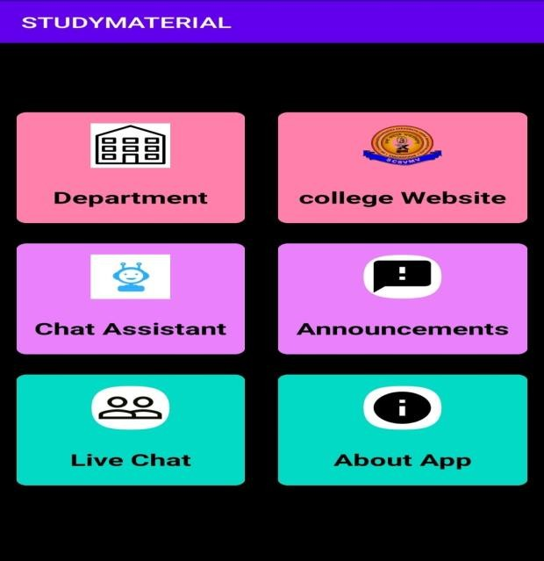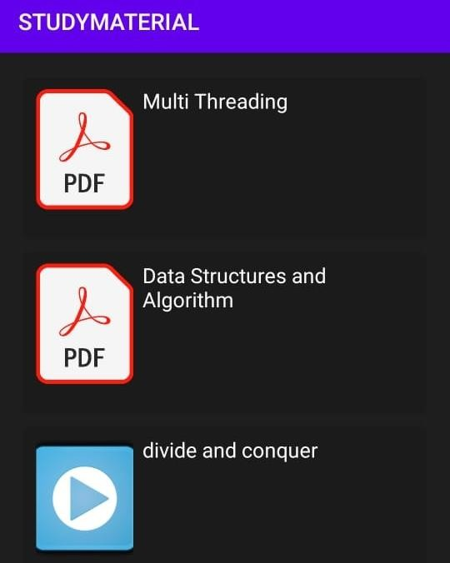

### Results for Department selection

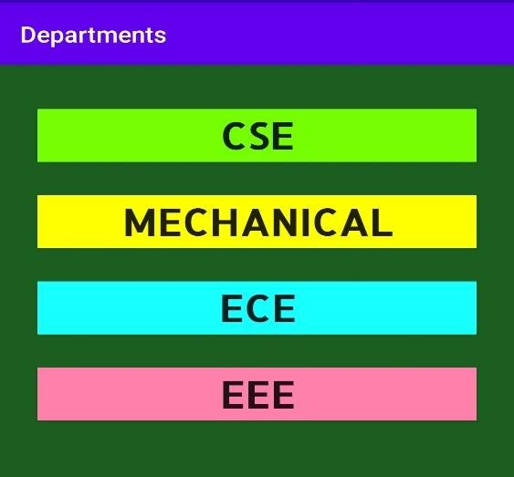

### Results for live chatting

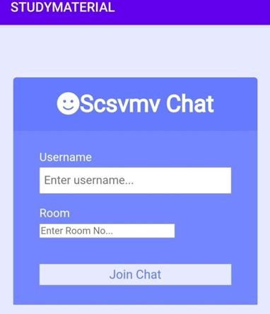

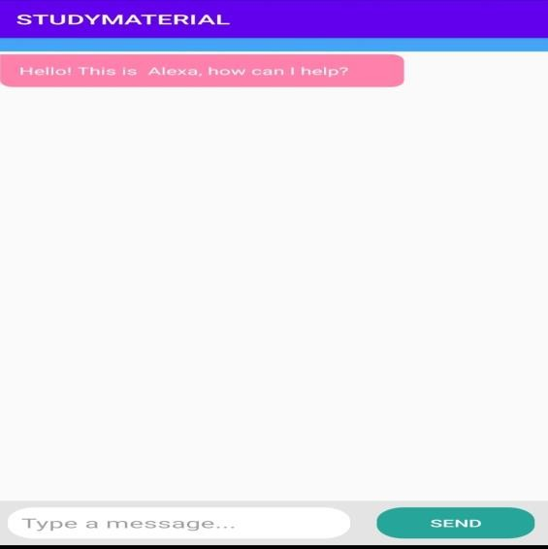

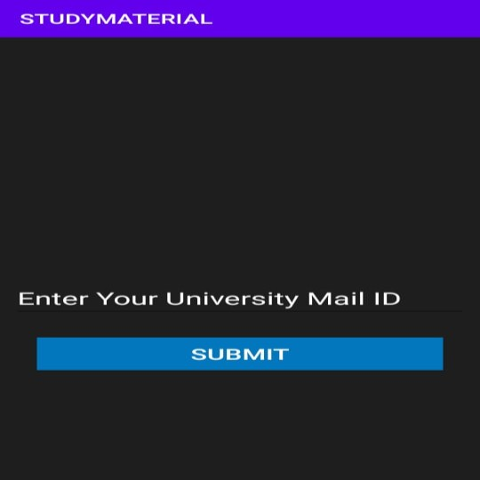

### Result for Announcements

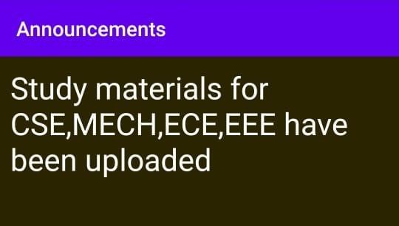

## Mongo DB Generation:

Mongo DB may be **a** cross-platform, document-oriented database that gives , high performance, high availability, and straightforward scalability. Mongo DB works on the concept of collection and document. Database is a physical container for collections. Each database gets its own set of files on the filing system . A single Mongo DB server typically has multiple databases. Collection is a group of Mongo DB documents. It is the equivalent of an RDBMS table. A collection exists within a single database. Collections do not enforce a schema. Documents within a collection can have different fields. Typically, all documents during **a** collection are **of** comparable or related purpose. A document is a set of key-value pairs. Documents have a dynamic schema. Dynamic schema means documents within the same collection don't got to have an equivalent set of fields or structure, and customary fields during **a** collection's documents may hold different types of data.

**SOURCE PROGRAM:**

import android.content.Intent;

import android.os.Bundle;

import android.view.View;

import android.widget.Button;

import androidx.appcompat.app.AppCompatActivity;

public class MainActivity extends AppCompatActivity {

@Override

protected void onCreate(Bundle savedInstanceState) {

super.onCreate(savedInstanceState);

setContentView(R.layout.activity_main);

Button btnTopic = findViewById(R.id.btnTopic);

btnTopic.setOnClickListener(v -> {

Intent intent = new Intent(MainActivity.this, DetailActivity.class);

startActivity(intent);

});

Button btnQuiz = findViewById(R.id.btnQuiz);

btnQuiz.setOnClickListener(v -> {

Intent intent = new Intent(MainActivity.this, QuizActivity.class);

startActivity(intent);

});

}

}

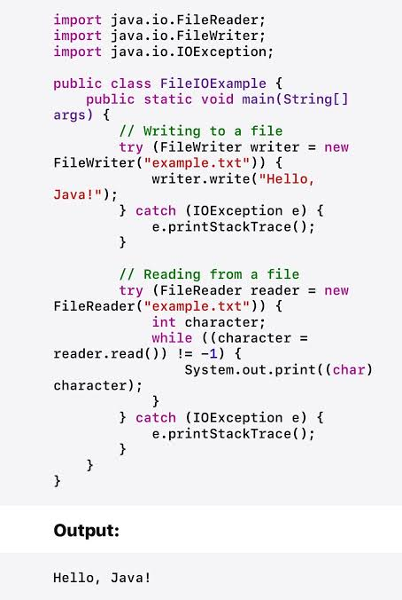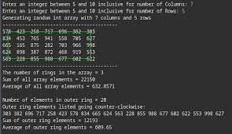

CONCLUSION:

This study material android application ensures that students are able to access their required study materials which are essential for their academics and also improves the communication between the students and teachers in online mode

The application can be enhanced by improving the chat assistant so that it can clarify most of the doubts of the students. Further the functionality to check the availability of a particular book in our university can be added to the application also all the study materials can be displayed

The above is the chat assistant screen where the student can get some assistance from the bots available .The chat assistant can understand some basic commands like opening Our university students portal, fee payment portal etc.